**ONLINE EXAMINATION PREPARATION SYSTEM**

**A PROJECT REPORT**

**for**

**Mini Project (KCA353)**

**Session (2023-24)**

**Submitted by**

**Mayank Gaur**

**(2200290140088)**

**Submitted in partial fulfilment of the**

**Requirements for the Degree of**

**MASTER OF COMPUTER APPLICATION**

**Under the Supervision of**

**Dr. Amit Kumar**

### **Assistant Professor**



**Submitted to**

**Department Of Computer Applications**

**KIET Group of Institutions, Ghaziabad**

**Uttar Pradesh-201206**

**(March 2024)**

**CERTIFICATE**

Certified that **Mayank Gaur (2200290140088)** has carried out the project work having “**Online Examination Preparation System**” (**Mini Project-KCA353**) for **Master of Computer Application** from Dr. A.P.J. Abdul Kalam Technical University (AKTU**)** (formerly UPTU), Lucknow under my supervision. The project report embodies original work, and studies are carried out by the student himself and the contents of the project report do not form the basis for the award of any other degree to the candidate or to anybody else from this or any other University/Institution.

**Date:**

**Mayank Gaur**

**2200290140088**

This is to certify that the above statement made by the candidate is correct to the best of my knowledge.

Date:

**Dr. Amit Kumar Dr. Arun Tripathi**

**Assistant Professor Head**

**Department of Computer Applications Department of Computer Applications**

**KIET Group of Institutions KIET Group of Institutions**

**Ghaziabad Ghaziabad**

**Online Examination Preparation Assistant**

**Mayank Gaur**

**ABSTRACT**

The advent of digital technology has transformed the way education is delivered and assessed. Online examinations have gained significant prominence in educational institutions, offering convenience, scalability, and efficiency. However, students often face challenges in preparing for these online exams, including time management, resource access, and effective study strategies. To address these issues, an innovative solution emerges: the Online Examination Preparation Assistant (OEPA).

OEPA is an *intelligent and user-friendly platform* designed to enhance the exam preparation process for students of all levels. The primary objective of OEPA is to empower students to achieve better academic outcomes by optimizing their study routines and assisting them in acquiring the necessary knowledge and skills.

The Online Examination Preparation Assistant represents a crucial step towards harnessing the potential of technology to enhance educational outcomes. By offering tailored guidance, resource recommendations, and performance analytics, OEPA aims to empower student to excel in their online examination, ultimately contributing to the advancement of digital education. As educational institutions continue to adopt online assessment methods, OEPA’s role in assisting students in their exam preparation becomes increasingly indispensable.

**ACKNOWLEDGEMENTS**

Success in life is never attained single-handedly. My deepest gratitude goes to my project supervisor, **Dr. Amit Kumar, Assistant Professor** for his guidance, help, and encouragement throughout my project work. Their enlightening ideas, comments, and suggestions.

Words are not enough to express my gratitude to **Dr. Arun Kumar Tripathi**, Professor and Head, Department of Computer Applications, for his insightful comments and administrative help on various occasions.

Fortunately, I have many understanding friends, who have helped me a lot on many critical conditions.

Finally, my sincere thanks go to my family members and all those who have directly and indirectly provided me with moral support and other kind of help. Without their support, completion of this work would not have been possible in time. They keep my life filled with enjoyment and happiness.

**Mayank Gaur**

**(2200290140088)**

**TABLE OF CONTENTS**

|  |  |  |  |  |
| --- | --- | --- | --- | --- |
|  | Certificate | | | ii |
|  | Abstract | | | iii |
|  | Acknowledgements | | | iv |
|  | Table of Contents | | | v |
|  | List of Tables | | | vi |
|  | List of Figures | | | vii |
| 1 | Introduction | | | 8-9 |
|  | 1.1 | Project Description | | 8 |
|  |  | 1.1.1 | Admin Module | 8 |
|  |  | 1.1.2 | User Module | 8 |
|  | 1.2 | Project Scope | | 8 |
|  | 1.3 | Hardware/Software Used | | 9 |
|  |  | 1.3.1 Hardware Requirements | | 9 |
|  |  | 1.3.2 Software Requirements | | 9 |
| 2 | Feasibility Study | | | 10 |
|  | 2.1 | Technical Feasibility | | 10 |
|  | 2.2 | Operational Feasibility | | 10 |
|  | 2.3 | Behavioural Feasibility | | 10 |
| 3 | Design | | | 11-17 |
|  | 3.1 Use Case Diagram | | | 11 |
|  | 3.2 E-R Diagram | | | 12 |
|  | 3.3 Database Design | | | 13 |
|  | 3.4 Data Flow Diagram | | | 15-17 |
|  | 3.4.1 Level – 0 DFD | | | 15 |
|  | 3.4.2 Level – 1 DFD | | | 16 |
|  | 3.4.3 Level – 2 DFD | | | 17 |
| 4 | Testing | | | 18-20 |
|  | 4.1 Introduction | | | 18 |
|  | 4.2 Types of Testing | | | 18 |
|  | 4.2.1 Unit Testing | | | 18 |
|  | 4.2.2 Integration Testing | | | 19 |
| 5 | Conclusion and Future Scope | | | 21 |
| 6 | Project Screenshot | | | 23 |
| 7 | Bibliography | | | 32 |
|  |  | | |  |

**LIST OF TABLES**

|  |  |  |
| --- | --- | --- |
| **Table No.** | **Name of Table** | **Page** |
| 1.3.1 | Hardware Requirements | 9 |
| 1.3.2 | Software Requirements | 9 |
| 3.1 | Admin Table | 13 |
| 3.2 | Student Table | 13 |
| 3.3 | Course Table | 14 |
| 3.4 | Question Table | 14 |
| 3.5 | Exam Table | 14 |
| 3.6 | Session Table | 15 |

**LIST OF FIGURES**

|  |  |  |
| --- | --- | --- |
| **Figure No.** | **Name of Figure** | **Page No.** |
| 3.1 | Use Case Diagram | 11 |
| 3.2 | Entity-Relationship Diagram | 12 |
| 3.3 | Level – 0 DFD | 15 |
| 3.4 | Level – 1 DFD | 16 |
| 3.5 | Level – 2 DFD for Subject Update | 16 |
| 3.6 | Level – 2 DFD for Question Update | 17 |
| 3.7 | Level – 2 DFD for Exam Process | 17 |
| 6.1 | Home Page | 23 |
| 6.2 | Student Home Page | 23 |
| 6.3 | Student Sign-Up Page | 24 |
| 6.4 | Student Login Page | 24 |
| 6.5 | Student Dashboard | 25 |
| 6.6 | Student Examination Page | 25 |
| 6.7 | Student Marks Page | 26 |
| 6.8 | Admin Login Page | 26 |
| 6.9 | Admin Dashboard | 27 |
| 6.10 | Admin Student Section | 27 |
| 6.11 | Admin Course Section | 28 |
| 6.12 | Admin Add Course Section | 28 |
| 6.13 | Admin View Course Section | 29 |
| 6.14 | Admin Question Section | 29 |
| 6.15 | Admin Add Question Section | 30 |
| 6.16 | Admin Available Question Section | 30 |
| 6.17 | Admin View Question Section | 31 |

# **CHAPTER 1**

# **INTRODUCTION**

## **PROJECT DESCRIPTION**

In the rapidly evolving landscape of education, the adoption of online examination systems has ushered in a new era of convenience and accessibility for learners worldwide. However, as students embrace this digital transformation, they encounter a host of challenges in preparing effectively for online exams. These challenges range from structuring study routines and managing time efficiently to accessing the right educational resources and strategies. To address these hurdles and empower students in their quest for academic excellence, the Online Examination Preparation Assistant (OEPA) emerges as a groundbreaking solution.

Its overarching goal is to enhance the overall exam preparation experience by offering a comprehensive suite of features and tools designed to cater to the unique needs of each learner. In a world where educational demands continue to evolve, OEPA is positioned as an indispensable companion for students on their journey towards academic success.

In OEPA project we use SQLite database. It has two modules.

### **ADMIN MODULE**

* Administrators can manage course content, including adding, editing, or deleting courses and study materials.
* Administrators can view user accounts, reset passwords, and suspend or delete accounts when necessary.
* Administrators can generate system performance reports.

### **USER MODULE**

* User Registration
* User Login
* Course Selection
* Practice Exams

## **PROJECT SCOPE**

The scope of Online Examination Preparation Assistant (OEPA) is to create a website through which students can prepare for their various examinations. This website can help hundreds of students to achieve their goal with ease.

# **HARDWARE/SOFTWARE USED:**

## **HARDWARE REQUIREMENTS:**

**Table 1.3.1 Hardware Requirements**

|  |  |
| --- | --- |
| **Hardware Used** | **Configuration** |
| PROCESSOR | I3 |
| RAM | 4GB |
| HARD DISK | 40 GB |
| OPERATING SYSTEM | Windows 10 or above |

## **SOFTWARE REQUIREMENTS:**

**Table 1.3.2 Software Requirements**

|  |  |
| --- | --- |
| IDE | VS Code |
| Frontend | HTML and CSS |
| Client-Side Scripting | JavaScript |
| Server-Side Scripting | Python |
| Framework | Django |
| Database | SQLite |

# **CHAPTER 2**

# **FEASIBILITY STUDY**

A feasibility study is a high-level capsule version of the entire System analysis and Design Process. The study begins by classifying the problem definition. Feasibility is to determine if it’s worth doing. Once an acceptance problem definition has been generated, the analyst develops a logical model of the system. A search for alternatives is analysed carefully. There are 3 parts in feasibility study.

# **2.1 TECHNICAL FEASIBILITY**

Does the necessary technology exist to do what is been suggested Does the proposed equipment have the technical capacity for using the new system? Are there technical guarantees of accuracy, reliability, and data security? The project is developed on Ryzen with 128 MB RAM. The environment required in the development of system is any windows platform. The language used in the development is Python, Django as a framework and SQLite as database.

# **2.2 OPERATIONAL FEASIBILITY**

Question that going to be asked are Will the system be used if it developed and implemented. If there was sufficient support for the project from the management and from the users. Have the users been involved in planning and development of the Project.

# **2.3 BEHAVIOURAL FEASIBILITY**

The behavioural feasibility of an Online Examination Preparation Assistant project refers to its practicality and viability from a user perspective. It assesses whether the proposed system aligns with the intended users' needs, expectations, and behaviours. The behavioural feasibility of an online examination preparation assistant project refers to the assessment of whether the proposed system can be accepted and effectively used by the users and stakeholders.

**CHAPTER 3**

# **DESIGN**

# **3.1 Use Case Diagram:**

Use case diagram consists of actors, use cases and their relationships. These diagrams are especially important in organizing and modelling the behaviours of a system.

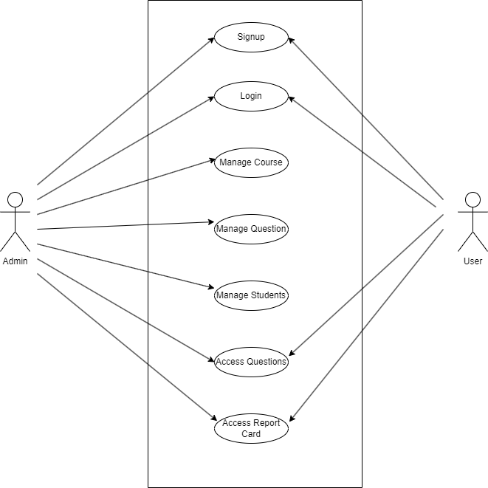

**Fig 3.1 Use Case Diagram**

**3.2 Entity Relationship Diagram (E-R Diagram):**

An Entity Relationship (ER) Diagram is a type of flowchart that illustrates how “entities” such as people, objects or concepts relate to each other within a system.

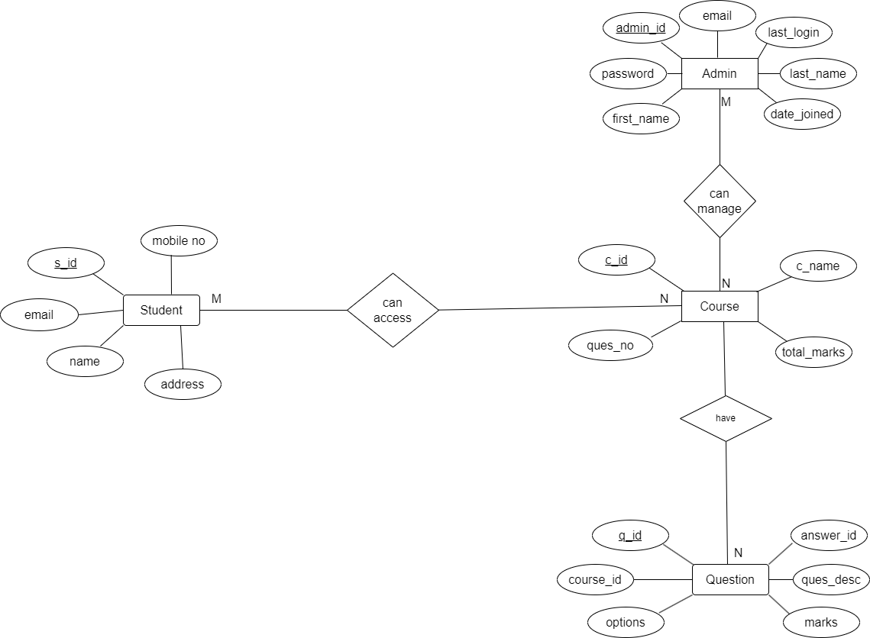

**Fig 3.2 Entity Relationship Diagram**

## **3.3 DATABASE DESIGN**

The data in the system must be stored and retrieved from database. Designing the database is part of system design. Data elements and data structures to be stored have been identified at analysis stage. They are structured and put together to design the data storage and retrieval system.

A database is a collection of interrelated data stored with minimum redundancy to serve many users quickly and efficiently. The general objective is to make database access easy, quick, inexpensive, and flexible for the user. Relationships are established between the data items and unnecessary data items are removed. Normalization is done to get an internal consistency of data and to have minimum redundancy and maximum stability. This ensures minimizing data storage required, minimizing chances of data inconsistencies, and optimizing for updates. The SQLite is a by default database of Django framework which used to access database has been chosen for developing the relevant databases.

## **3.3.1 Table_Admin:** This table is used to store the details about the admin.

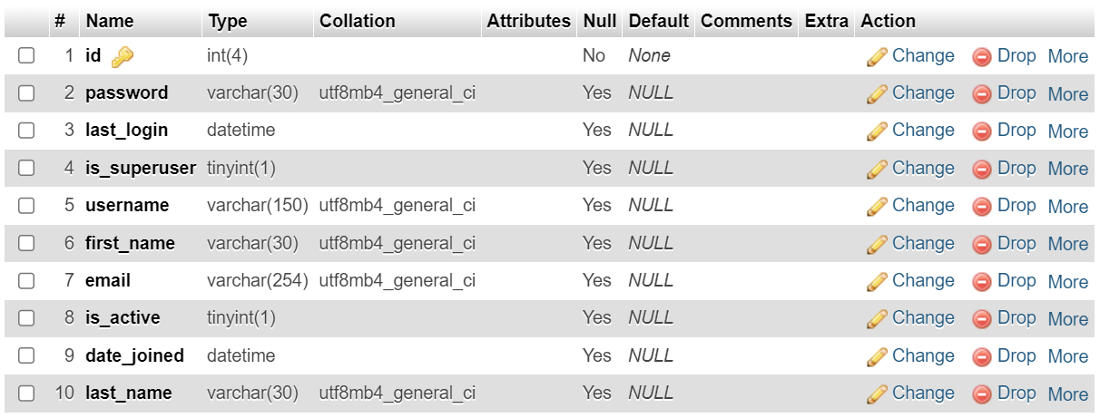

**Table 3.1 Admin Table**

## **3.3.2 Table_Student:** This table is used to store details about students.

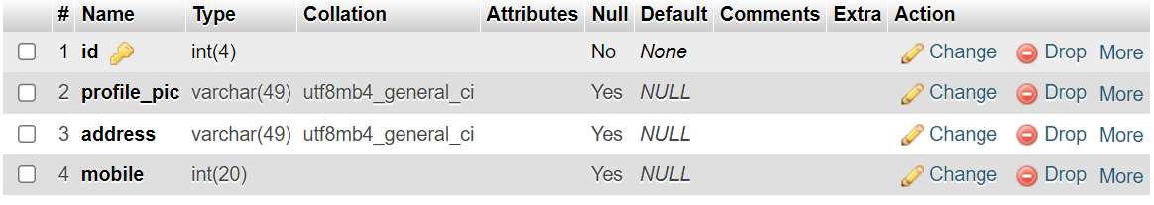

**Table 3.2 Student Table**

## **3.3.3 Table_Course:** This table is used to store the information about course.

**Table 3.3 Course Table**

## **3.3.4 Table_Question:** This table is used to store the information about the question.

**Table 3.4 Question Table**

## **3.3.5 Table_Exam:** This table is used to store the information about exam.

**Table 3.5 Exam Table**

## **3.3.6 Session_Table:** This table is used for session tracking.

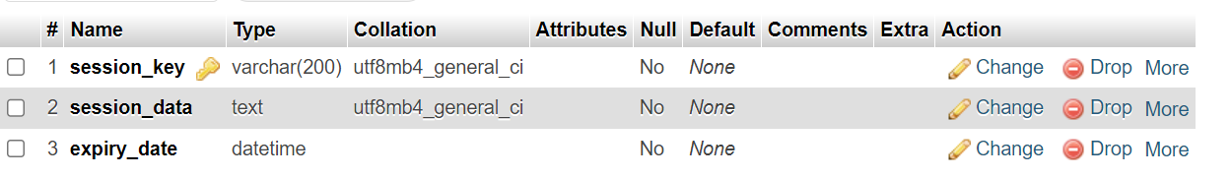

**Table 3.6 Session Table**

# **3.4 Data Flow Diagram (DFD):**

DFD is the abbreviation for Data Flow Diagram. The flow of data of a system or a process is represented by DFD. It also gives insight into the inputs and outputs of each entity and the process itself. DFD does not have control flow and no loops or decision rules are present. Specific operations depending on the type of data can be explained by a flowchart. It is a graphical tool, useful for communicating with users, managers, and other personnel. it is useful for analysing existing as well as proposed system.

## **3.4.1 DFD for Level-0:**

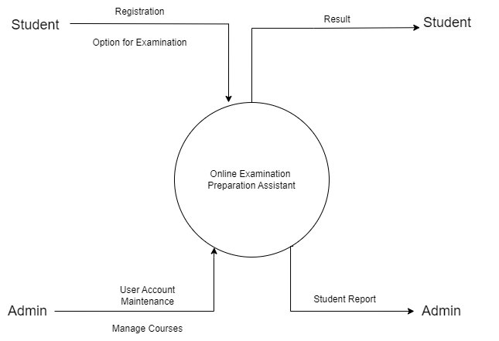

**Fig.3.3 Level-0 DFD**

## **3.4.2 DFD for Level-1:**

**Fig.3.4 Level-1 DFD**

## **3.4.3 DFD for Level-2:**

**Fig.3.5 Level-2 DFD for Updating Subjects**

**Fig.3.6 Level-2 DFD for Updating Questions**

**Fig.3.7 Level-2 DFD for Exam Process**

**CHAPTER 4**

**TESTING**

**4.1 INTRODUCTION**

The purpose of testing is to discover errors. Testing is the process of trying to discover every conceivable fault or weakness in a work product. It provides a way to check the functionalities of components, sub-assemblies, and/or a finished product it is the process of exercising software with the intent of ensuring that the software system meets its requirements and user expectations and does not fail in an unacceptable manner. There are various types of tests. Each test type addresses a specific testing requirement.

Let’s find out possible test scenarios or cases for the online examination system. As you can see from the online examination portal, two types of users.

* **Teacher or Admin:** who is responsible for adding questions to the portal.
* **Students or users:** who answers the questions.

**4.2 TYPES OF TESTING**

**4.2.1 Unit Testing**

Unit testing focuses verification effort on the smallest unit of software design, the module. The unit testing, we have is white box oriented and some modules the steps are conducted in parallel.

### **Test Cases for Student**

* Check that all the mandatory fields are filled on the user profile page.
* Check if there is any option for changing the password.
* Check students can log in after entering valid credentials. He should be able to see course questions.
* Check whether a user can choose the exam by clicking on the exam name for the exam code.
* Check If the user clicks the ok button, the user should be redirected to the exam page.
* If the question is multiple, the choices should be displayed below the questions, and there should be an option to select the correct answer.
* Check if there is an option to skip a particular question.
* Once a user completes or answers all the questions, he should be able to end the test.
* Check if all the questions are multiple questions; then, after the completion of the test, evolution should be performed based on positive and negative markings.
* Based on the evolution, the result should be displayed with the correct answer percentage in the pass or fail.

### **Test Cases for Admin**

* Check the user has the option to change the password.
* Check for the admin that should be an option for adding a new subject.
* Check after clicking on the subject name. The teacher should be able to add questions under the subject.
* After a click on the subject name, there should be an option for creating exams.
* Check to create a new exam. To enter the exam code, the admin must fill in some mandatory fields like exam name and subject name.
* Check whether a admin can set the number of questions and pass a percentage of the foreign exams.
* Check based on the number of questions it should display accordingly.
* The admin can enter the question and multiple-choice options in the respective fields.

**4.2.2. Integration Testing**

Testing is done for each module. After testing all the modules, the modules are integrated and testing of the final system is done with the test data, specially designed to show that the system will operate successfully in all its aspects conditions. Thus the system testing is a confirmation that all is correct and an opportunity to show the user that the system works. The purpose of integration testing is to verify functional, performance and reliability requirements placed on major design items. These "design items", i.e. assemblages (or groups of units), are exercised through their interfaces using black box testing, success and error cases being simulated via appropriate parameter and data inputs. Simulated usage of shared data areas and inter-process communication is tested, and individual subsystems are exercised through their input interface.

### **Test Cases for System**

* Check If a user enters the address section of the browser and hits enter, the application should be open.
* Check the application is loading properly.
* Ensure all the portal’s images, logos, and text are visible.
* Check the application login functionality.
* Check that only users with valid credentials can log into the application.

**CHAPTER 5**

**CONCLUSION & FUTURE SCOPE**

**5.1 Conclusion**

In conclusion, the Online Examination Preparation Assistant project serves as an invaluable tool in the realm of education, offering a comprehensive and user-friendly platform to aid students in their exam preparation journey. The project's key features, such as personalized study plans, interactive practice tests, and real-time performance analytics, empower students to optimize their learning experience.

As we move forward, the project can serve as a foundation for further innovations in the educational technology landscape, supporting the ongoing efforts to make learning more accessible, efficient, and enjoyable.

**5.2 Future Scope**

The Online Examination Preparation Assistant project holds immense potential for future expansion and enhancement. Here are several avenues for future scope:

**5.2.1 Adaptive Learning Algorithms:**

Implementing advanced adaptive learning algorithms can personalize the study plans even further. By continuously analysing individual performance and learning patterns, the system can dynamically adjust the difficulty level of questions, ensuring an optimized learning experience for each student.

**5.2.2 Integration of AI-driven Virtual Tutors:**

Introducing AI-driven virtual tutors can provide real-time assistance and feedback to students. These virtual tutors can help clarify doubts, offer explanations for complex topics, and guide students through their preparation, creating a more interactive and supportive learning environment.

**5.2.3 Expanded Content Repository:**

Continuously updating and expanding the question bank and study materials will ensure that the platform remains relevant and aligned with evolving curriculum standards. Collaborations with educators and subject matter experts can contribute to a rich and diverse content repository.

**5.2.4 Multilingual Support:**

To cater to a global audience, incorporating multilingual support can make the Online Examination Preparation Assistant accessible to students from different linguistic backgrounds. This can enhance its usability and broaden its reach in diverse educational landscapes.

**5.2.5 Enhanced Analytics and Reporting:**

Further refining analytics and reporting features can provide more detailed insights into student performance. This includes identifying specific areas of strength and weakness, tracking progress over time, and generating comprehensive reports that can be valuable for both students and educators.

**CHAPTER 6**

**PROJECT SCREENSHOT**

## **6.1 HOME PAGE**

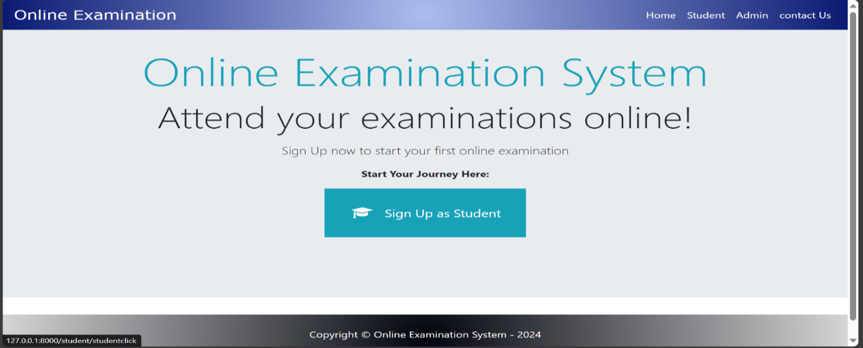

**Fig.6.1 Home Page**

## **6.2 STUDENT HOME PAGE**

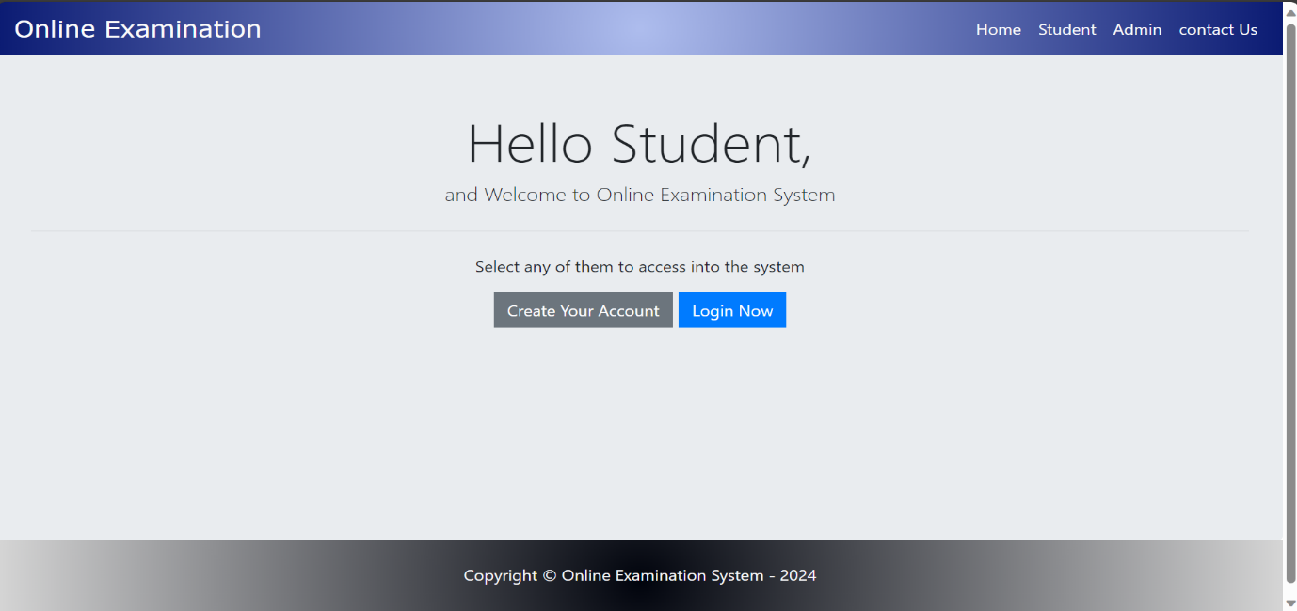

**Fig.6.2 Student Home Page**

## **6.3 STUDENT SIGN-UP PAGE**

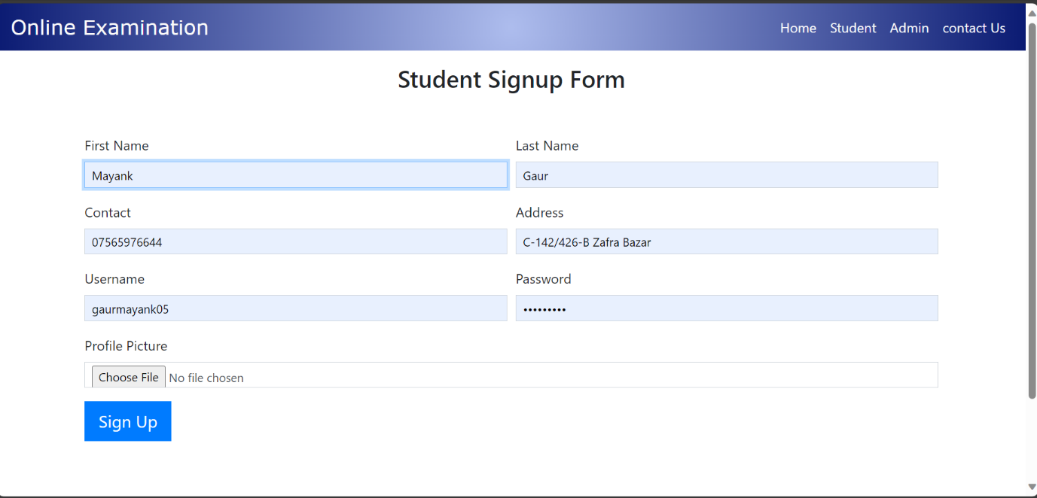

**Fig.6.3 Student Sign-Up Page**

**6.4 STUDENT LOGIN PAGE**

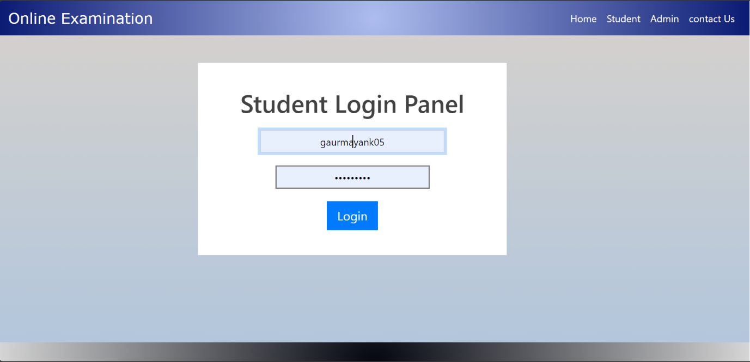

**Fig.6.4 Student Login Page**

**6.5 STUDENT DASHBOARD**

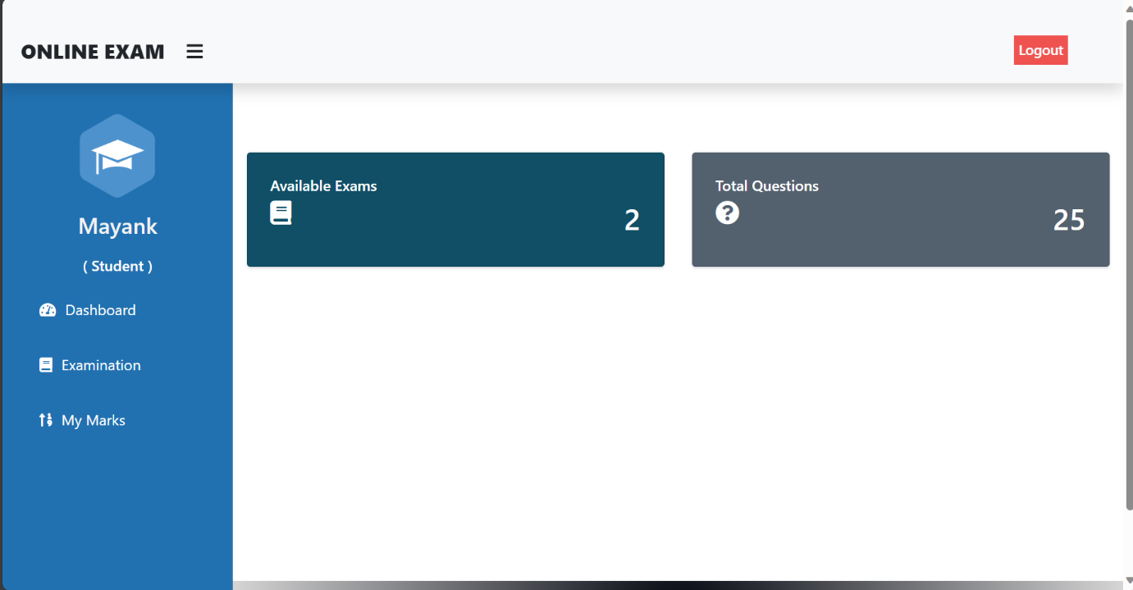

**Fig.6.5 Student Dashboard**

**6.6 STUDENT EXAMINATION PAGE**

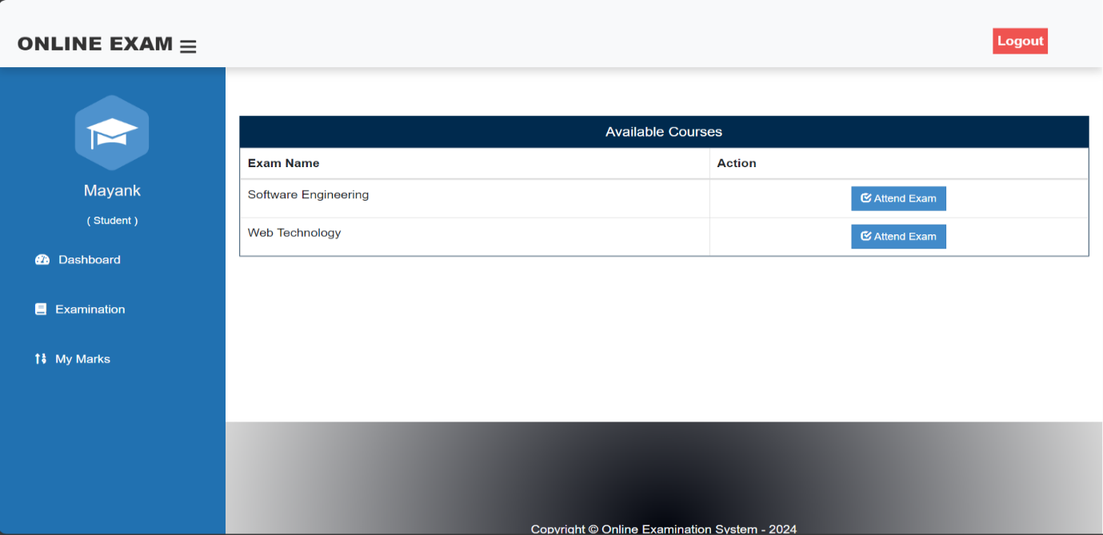

**Fig.6.6 Student Examination Page**

**6.7 STUDENT MARKS PAGE**

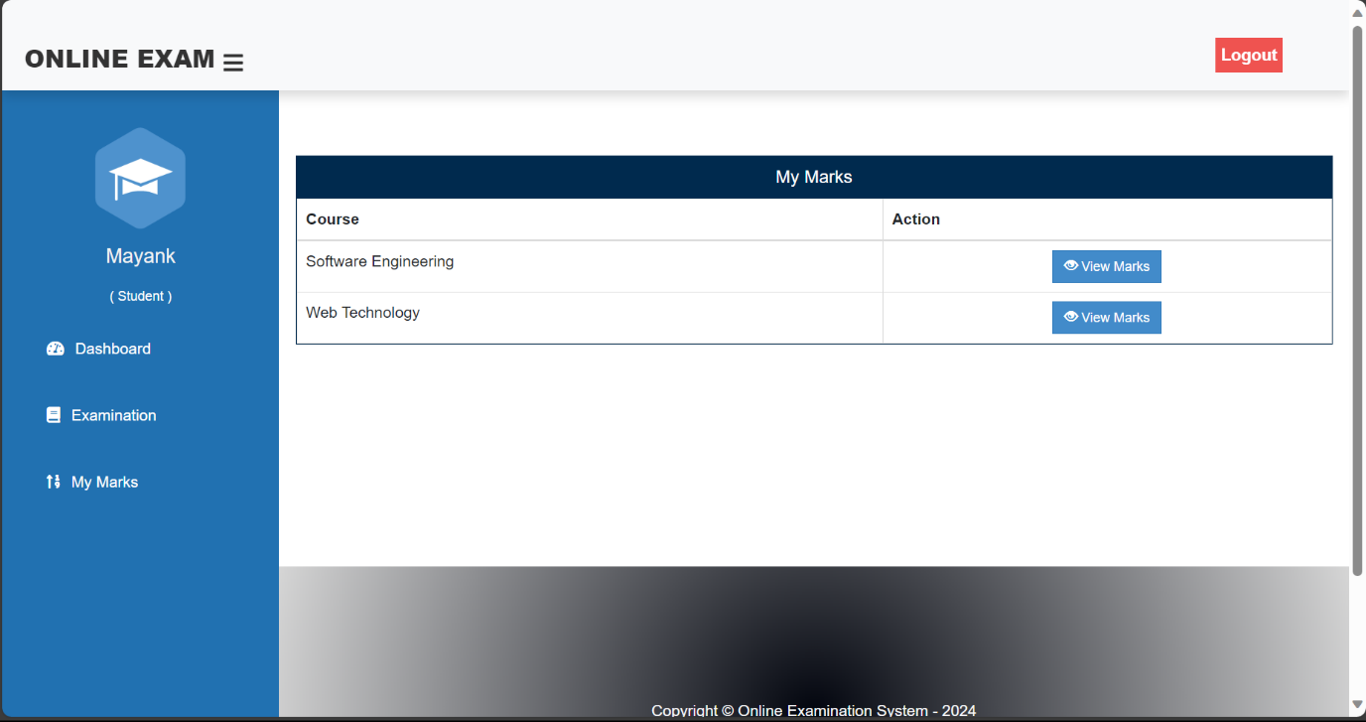

**Fig.6.7 Student Marks Page**

**6.8 ADMIN LOGIN PAGE**

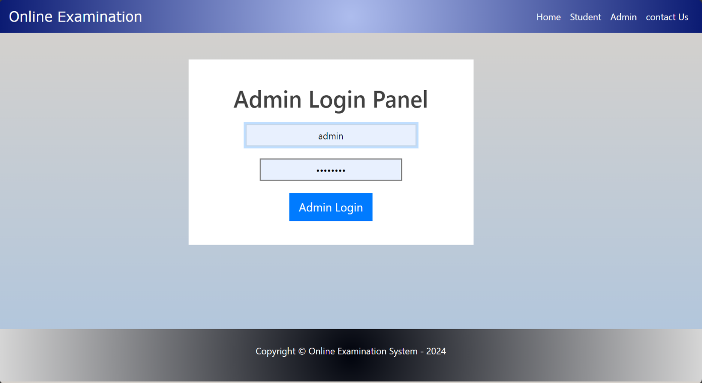

**Fig.6.8 Admin Login Page**

**6.9 ADMIN DASHBOARD**

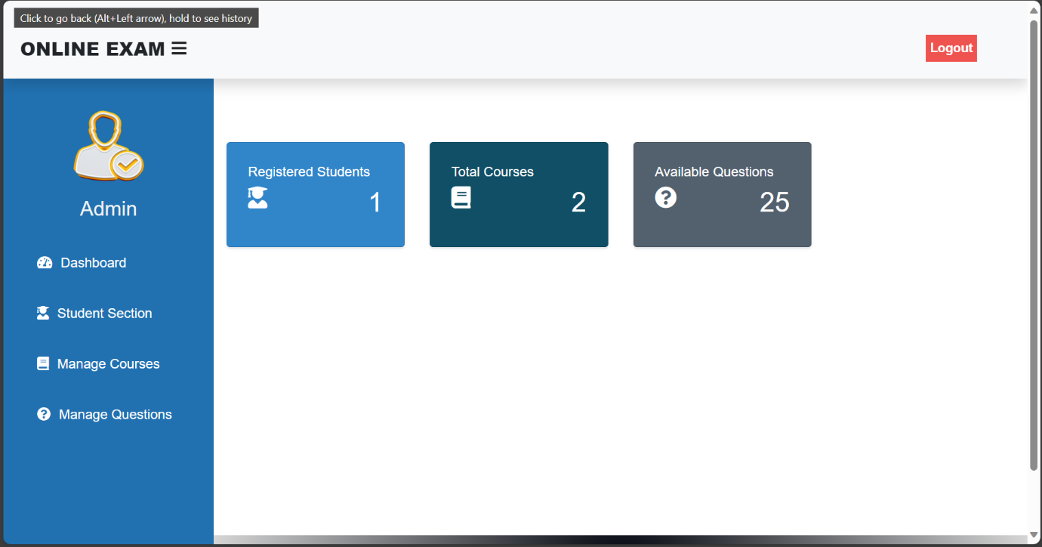

**Fig.6.9 Admin Dashboard**

**6.10 ADMIN STUDENT SECTION**

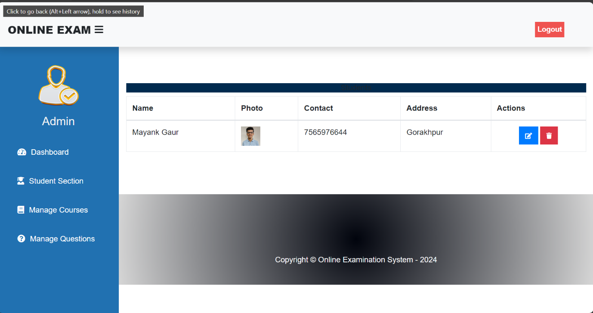

**Fig.6.10 Admin Student Section**

**6.11 ADMIN COURSE SECTION**

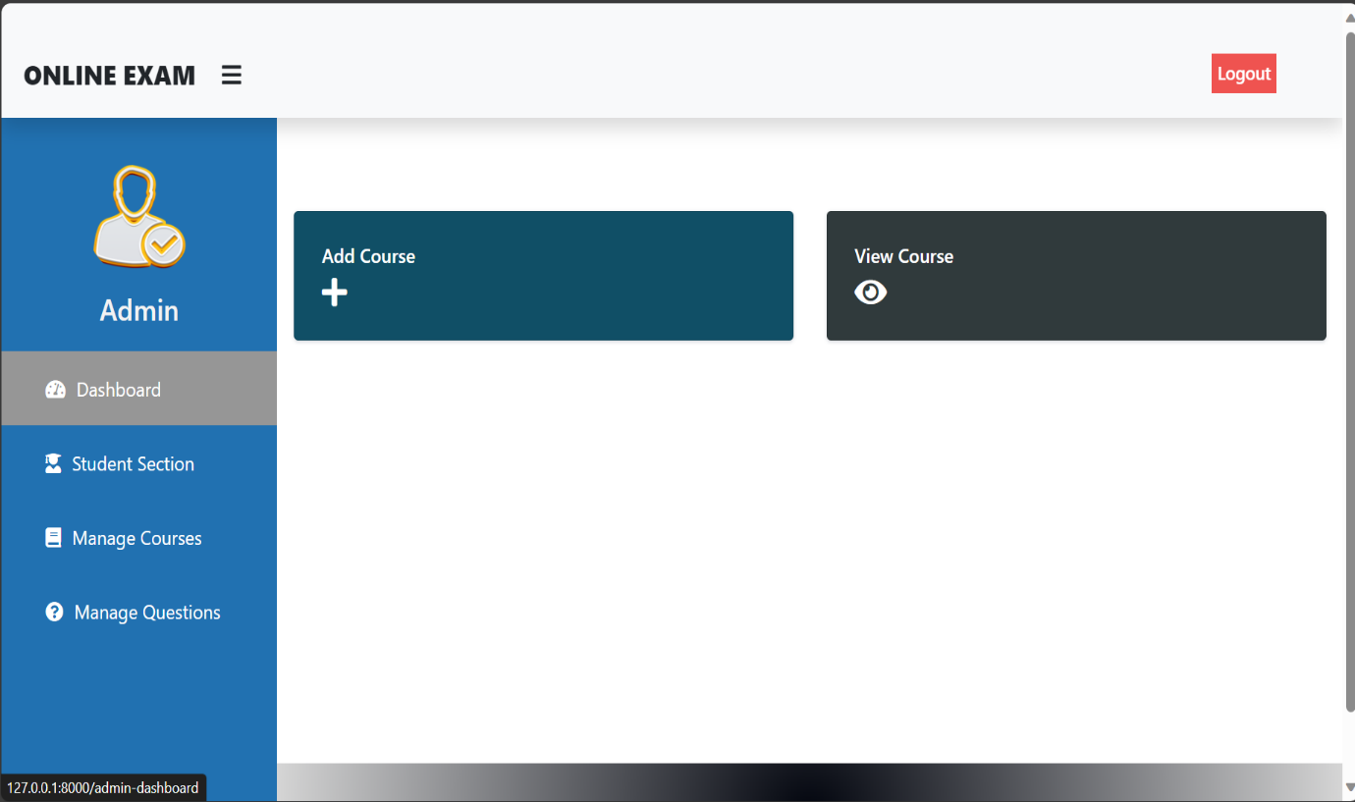

**Fig.6.11 Admin Course Section**

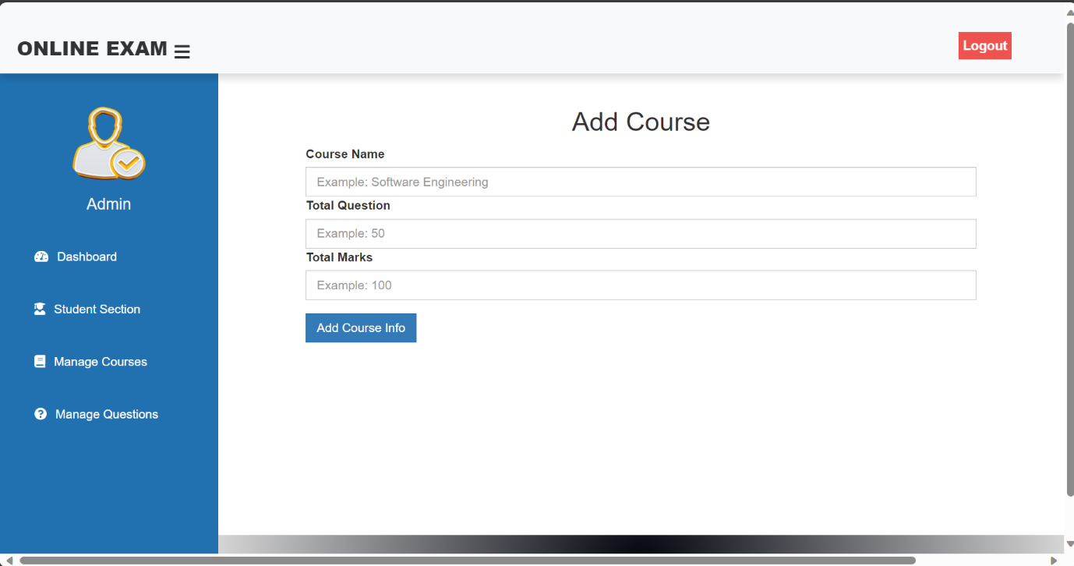

**Fig.6.12 Admin Add Course Section**

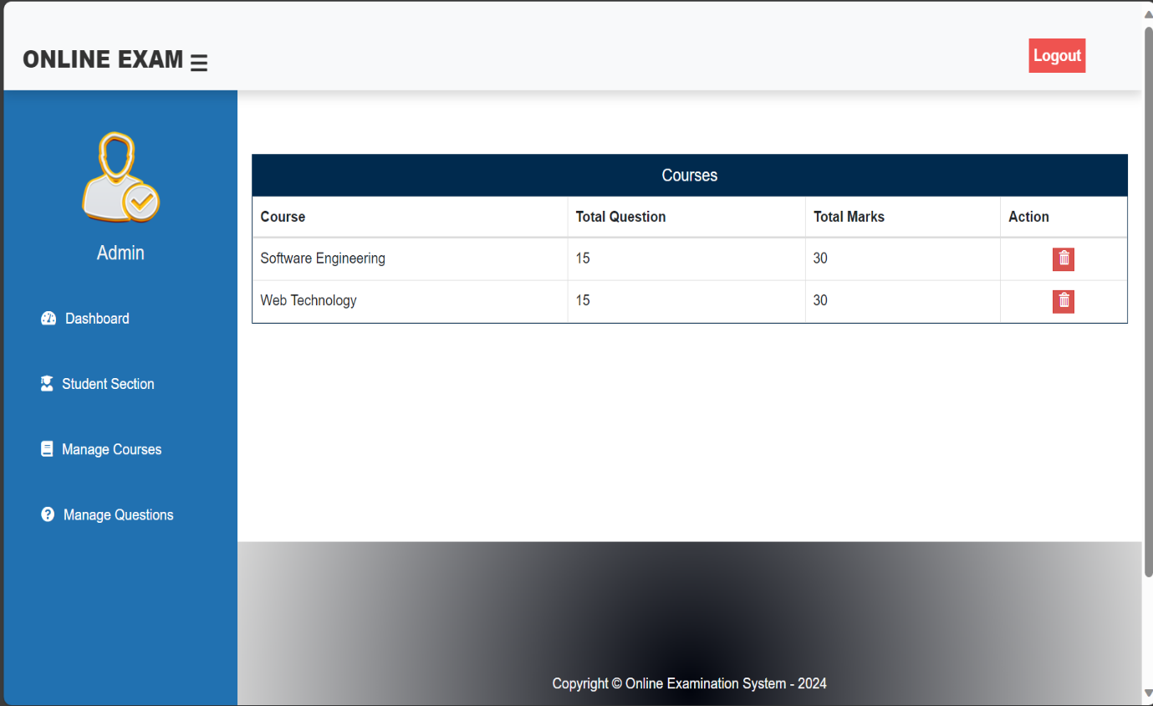

**Fig.6.13 Admin View Course Section**

**6.12 ADMIN QUESTION SECTION**

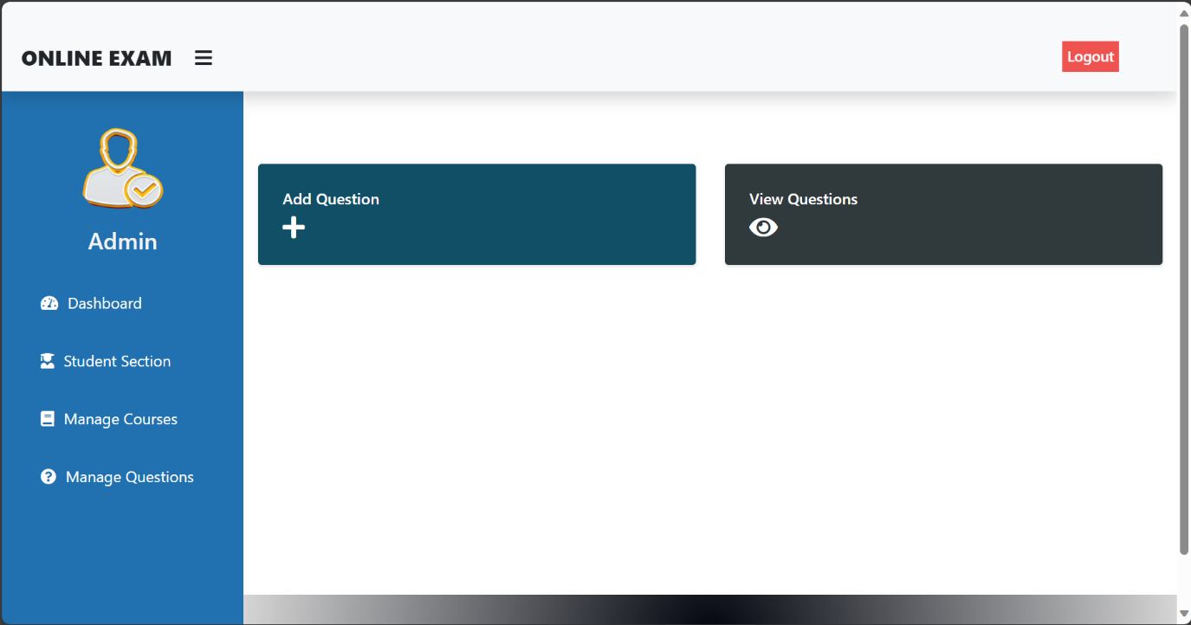

**Fig.6.14 Admin Question Section**

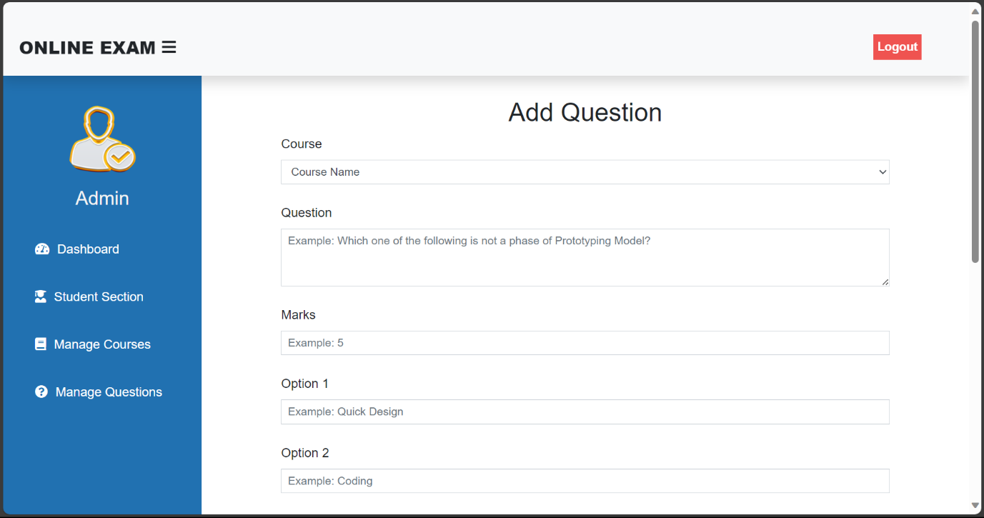

**Fig.6.15 Admin Add Question Section**

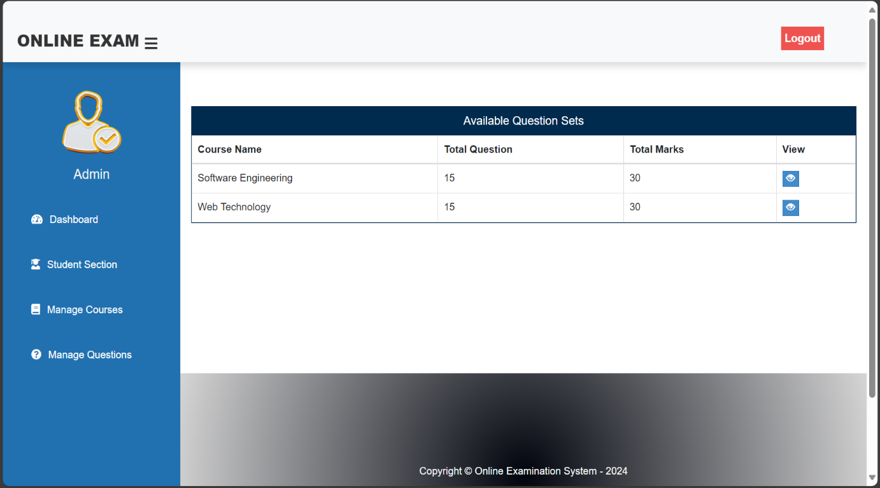

**Fig.6.16 Admin Available Question Section**

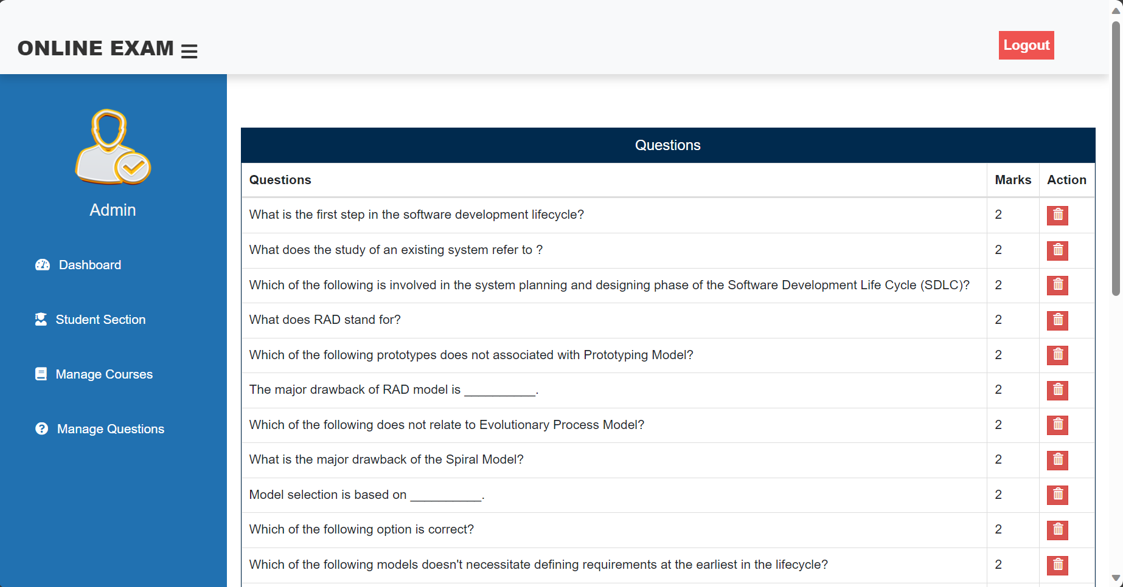

**Fig.6.17 Admin View Question Section**

# **CHAPTER 7**

# **BIBLIOGRAPHY**

* Software Engineering K.K. Aggarwal and Yogesh Singh
* <https://www.w3schools.com/>
* <https://www.geeksforgeeks.org/><https://projectworlds.in/free-projects/php-projects/online-examination/>
* <https://123projectlab.com/dfd-for-online-examination-system/>